1. **Project Setup and Initial Design (Week 1–2: Aug 28 – Sept 10)**
   * Finalize project plan, design UI/UX for both student and vendor interfaces.
   * Prepare database schema and system architecture.
   * Set up initial tools and environment.
2. **Backend and API Development (Week 3–4: Sept 11 – Sept 19)**
   * Develop API for document upload and storage in MongoDB.
   * Integrate secure payment gateway.
   * Initial setup for Printer Spooler API integration.
3. **Frontend Development (Week 5: Sept 19 – Sept 19)**
   * Start working on the React-based cross-platform interface for students.
   * Initial UI design for the vendor side desktop application.

**Break due to exams (Sept 20 – Oct 5)**

1. **Resume Frontend Development (Week 6: Oct 6 – Oct 12)**
   * Continue frontend development for both student and vendor interfaces.
   * Implement UI for uploading documents, selecting print preferences, and processing payments.
2. **Printer Spooler API and Vendor App (Week 7: Oct 13 – Oct 19)**
   * Integrate C++ Printer Spooler API for vendor-side application.
   * Test and connect printers with vendor application.
3. **Testing: Unit and Integration (Week 8: Oct 20 – Oct 26)**
   * Perform unit and integration testing on the backend API.
   * Test the frontend interactions and printer integration.
4. **UI Enhancements and Bug Fixes (Week 9: Oct 27 – Nov 2)**
   * Refine the user interface for both student and vendor sides.
   * Fix bugs from testing, optimize performance and usability.
5. **Vendor Training and Final Testing (Week 10: Nov 3 – Nov 8)**
   * Train vendors on the desktop application.
   * Conduct final user testing with students and vendors.
6. **Final Deployment and Project Wrap-Up (Week 11: Nov 9 – Nov 15)**
   * Final documentation and deployment of the application.
   * Monitor and resolve any post-deployment issues.

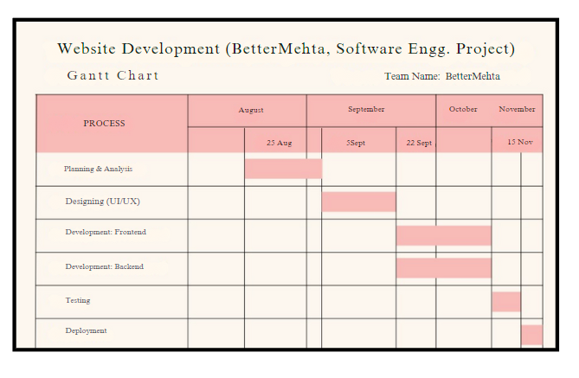

Open proj

Project libre